June 21, 2023
Ref: IIH/MD/2023/06/007

The Attorney General,
Kwara State Government,
Governor’s Office,
Ahmadu Bello Way,
GRA, Ilorin, Kwara State

Dear Sir,
IHS TOWERS COLLABORATION AGREEMENT REVIEW & EXECUTION
As a follow up to our Memorandum of Understanding with IHS Towers, here is a draft Collaboration Agreement for execution of details of the partnership. They have already started to meet up with their part of the agreement by paying vendors who have already moved to site to commence work on their contribution to the project, hence the need to urgently tidy this agreement. I would like to represent this for your review as well as review by the Ministry of Justice. Below is a summary of the terms in the Agreement:

- Parties Involved:
  - Kwara State Government (KWSG)
  - IHS (Nigeria) Limited (IHS)
- Purpose:
  - Follow-up agreement to previous MoU signed containing details and terms
- Scope of the MoU:
  - Hub Construction Contribution (commenced)
  - Hub Maintenance & Management
  - Ownership & Use of the Hub
  - The Programs
  - General Governance
  - Branding & Marketing
- My Recommendations:
  - We revise the total number of members of the board along with IHS members composition.
Attached is the full draft of the Collaboration Agreement for review and approval for execution. A soft copy will also be provided for edits and modification.

Yours sincerely,
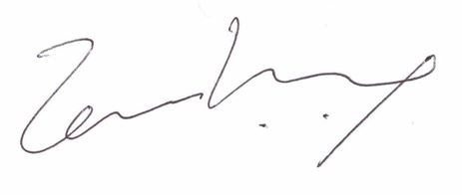
Temi Kolawole
ag. Managing Director

